**Submission for the Grasping System: Prateek Pawar**

# Functional Description

## Descprition of Design

The design consists of mainly two sections: 1) The Gripper System Actuated by one Servo motor. 2) The Arm system Providing Necessary degrees of freedom to gripper for different locations of objects. This system uses two duel shaft and one single shaft servo motors.

1. Standby:
   * How do you ensure that your GS does not move during this mode but it is able to receive commands? (R1)

**Ans:**

The Design mainly consists of Servo Motors as actuators; hence the GS doesn’t move any part during standby mode. The GS is controlled by an Arduino nano which continuously Receives commands from Serial Port.

1. Pick:

* How does your GS pick all the items in the possible positions? (R2)

**Ans:**

The Gripper is mounted on the Arm system which has 3 Servo motors providing Pitch, Yaw and Roll motion. These 3 DOF combined with 3 Cartesian DOF of the base robot as given in the problem Statement allows the gripper to reach any possible position and pick the object.

* How does your GS pick all the different items? (R2)

**Ans:**

The linkage design of the two finger Gripper is done in a way to provide it an variable opening from 3 mm to 65 mm. These limits include the width of all possible objects in the problem statement. Also, the gripper end has serrated rubber tips which can provide for any change in shape of the object and adjust accordingly by slightly deforming in shape of object.

The two extreme positions of the mechanism line diagram are as below:

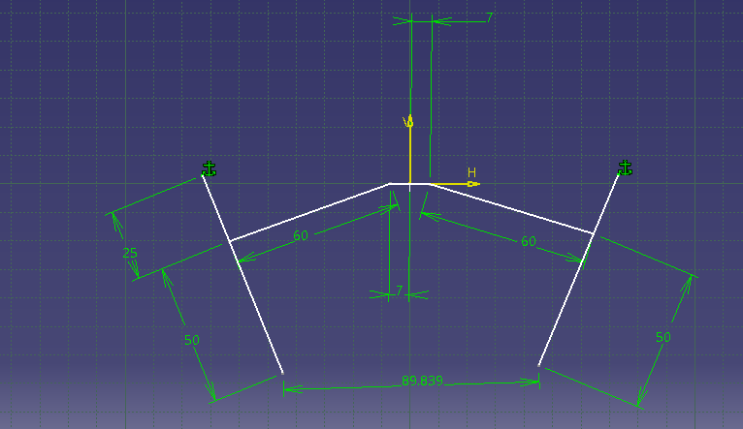 Max opening

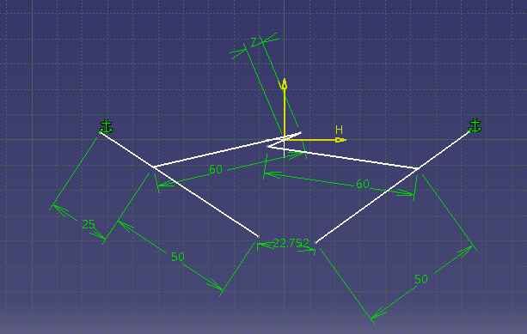

Minimum opening

Total Travel:67 mm

* How does your GS receive “pick” command? (R3)

**Ans:**

The Arduino nano Controlling the GS is connected to base robot using Serial Port as given in the Problem statement. When the string “pick” is given as Serial Input the GS will close the gripper and pick the object.

* How can it detect if an object is picked? (R4)

**Ans:**

Once the “pick” command is obtained and the gripper is closed the IR sensor behind gripper fingers detect the presence of object in the range of 25 mm .If the object is detected “Object picked “ command is printed in Serial monitor and if the object is not detected the command ”Object not picked “ is printed in the Serial monitor.

* What is gripping force provided for items of different widths?

**Ans:**

The gripping force is provided by the gripper servo motor having maximum torque of 10kg-cm. For items of different widths the gripping mechanism has different opening and different force transmission through linkages. By considering the force transmitted to the rubber grip and considering coefficient of friction between item and rubber as 0.3. following are the maximum masses od items that can be held by gripper:

1)Width=5mm Mass=2kg

2)Width=30 mm Mass=1.5 kg

3) Width=50mm Mass=0.8281 kg

1. Place:
   * How does your GS release the item? (R5, R6, R7)

**Ans:**

Once the robot is in required position the command “release” is to be sent to Serial port. The controller detects the “release” command in the Serial monitor and sends signal to the gripper servo motor to open. Once the Servo motor is opened the object is released. The command “itemReleased” is printed in Serial monitor.

* + How do you check if the item falls before “release” command is received? (R8)

**Ans:**

During the continuous loop of program, the variable p indicating item held if value is 1 is checked and if it is 1 the IR detects the object. If the object is not detected by IR, the message “itemFell” is printed in serial Monitor. And waiting for further command is done.

## Functional Analysis

In this section, describe your logic and/or analysis for your grasping system design by answering this following question:

1. How do you ensure that the picked item won’t be damaged?

**Ans:**

The Items are picked using a 2 finger gripper whose tips are made of serrated rubber shoes. Due to deformation of rubber according to item shape the gripping force will be distributed on the item. This will ensure that there is no damage to the item picked. Also the power of gripping Servo is Selected so that total gripping force is never more than 6 kg.

1. Is it possible to grab multiple item?

**Ans.**

No. This System is designed by considering width of one item to be picked at a time.

Hence it is not possible to grab multiple items.

1. What is the estimated total mass? (present it in a table consist of each components)

|  |  |  |  |
| --- | --- | --- | --- |
| No | Part | Material | Mass (gm) |
| 1 | Base plate1 | Aluminium | 12 |
| 2 | Pitch Motor | Plastic | 59 |
| 3 | Servo plate 1 | Aluminium | 14 |
| 4 | Base plate2 | Aluminium | 12 |
| 5 | Yaw Motor | Plastic | 59 |
| 6 | Servo plate 2 | Aluminium | 14 |
| 7 | Roll motor | Plastic | 55 |
| 8 | Grip Servo | Plastic | 55 |
| 9 | Servo Horn | Aluminium | 15 |
| 10 | IR Sensor Module | …. | 3 |
| 11 | Linkage Support | Aluminium | 20 |
| 12 | Crank 1 | Aluminium | 10 |
| 13 | Crank 2 | Aluminium | 10 |
| 14 | Lock pin 1 | Aluminium | 20 |
| 15 | Lock pin 2 | Aluminium | 20 |
| 16 | Arm 1 | Aluminium | 15 |
| 17 | Arm 2 | Aluminium | 15 |
| 18 | Rubber Shoe 1 | Rubber | 20 |
| 19 | Rubber Shoe 2 | Rubber | 20 |
| 20 | Gripper Motor Support | Aluminium | 20 |
| 21 | Arduino nano | … | 100 |
| 22 | 7 volt/ 3 Amp Adapter |  | 50 |
| 23 | Interface plate | Aluminium | 40 |
| 24 | Electronics Box | Plastic | 100 |
|  |  | **Total** | **758** |

# System layout

Main Systems:

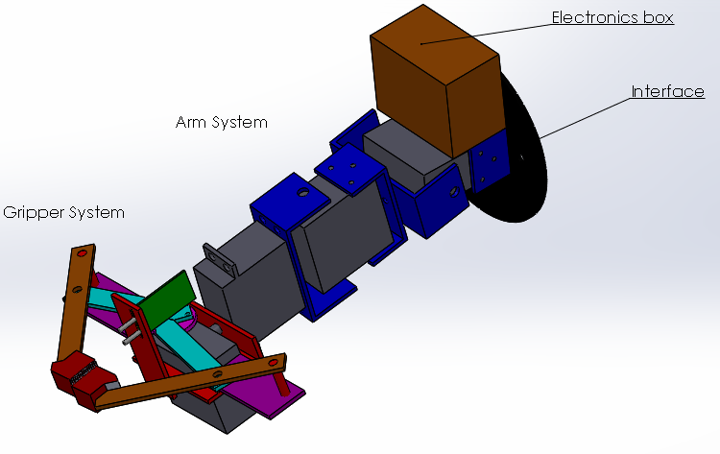

Exploded Views:

1. Arm System:

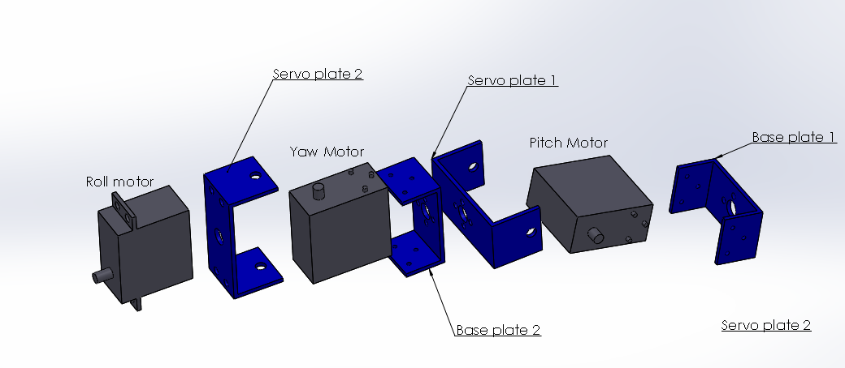

1. Gripper System:

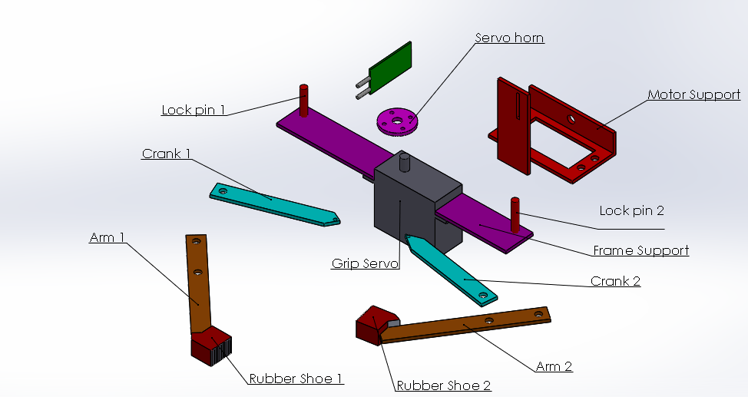

Electrical Circuit Diagram:

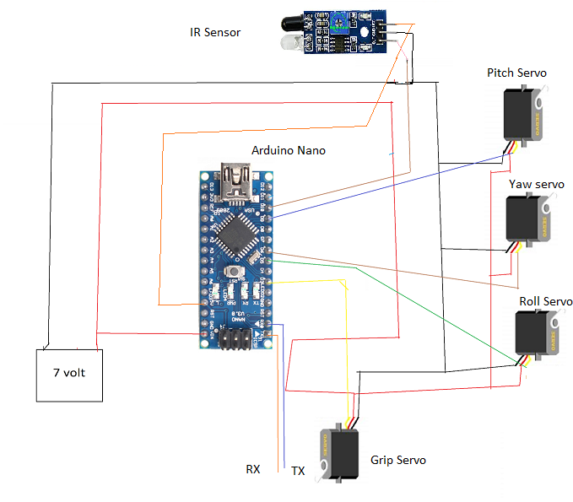

# Design drawings: 1) Arm System

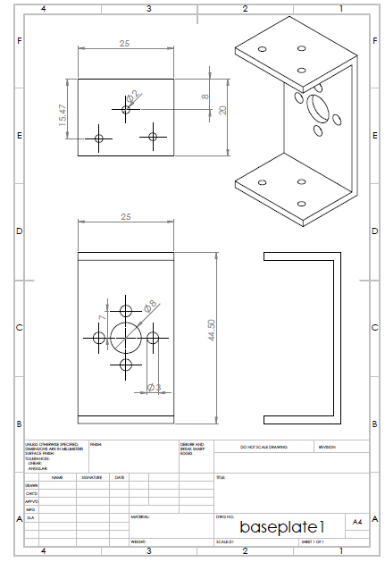

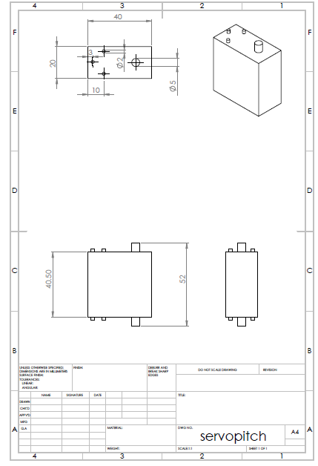

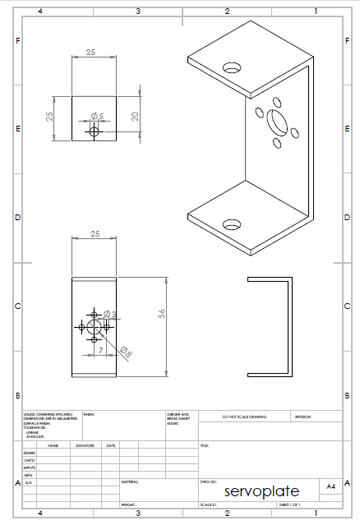

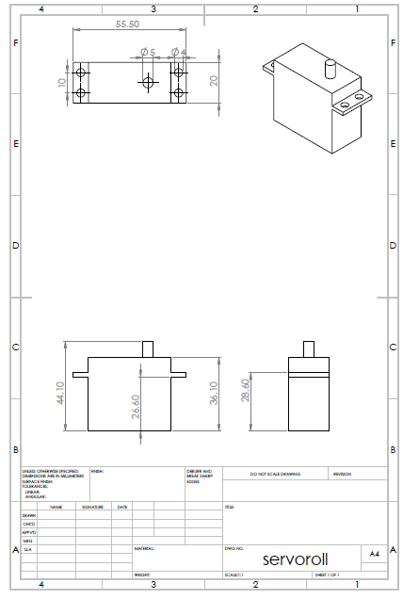

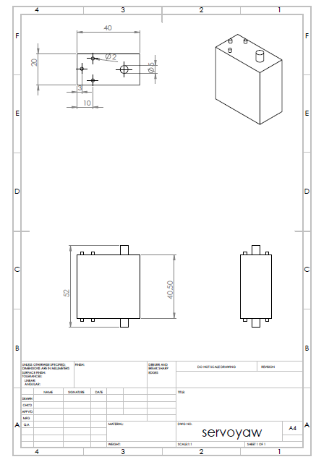

1. **Gripper System:**

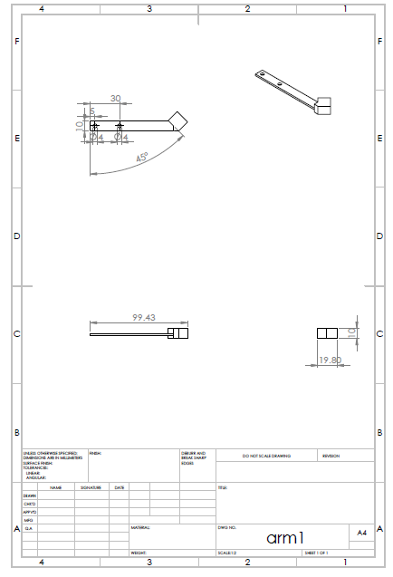

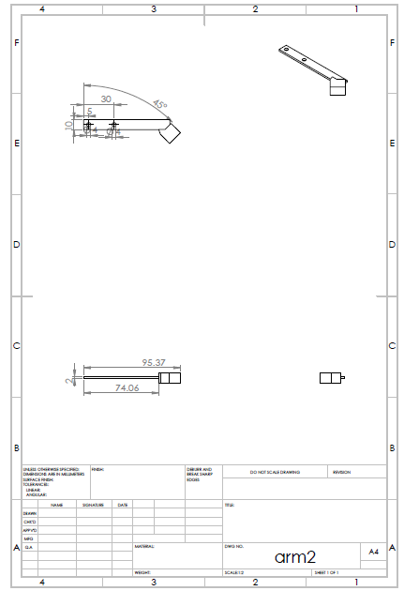

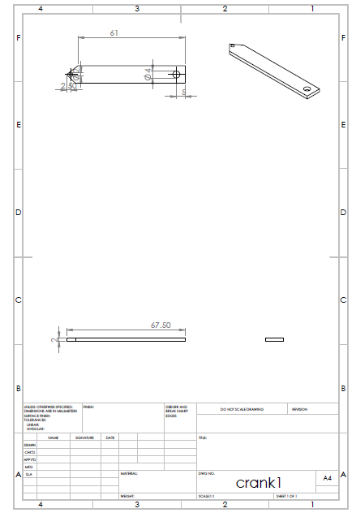

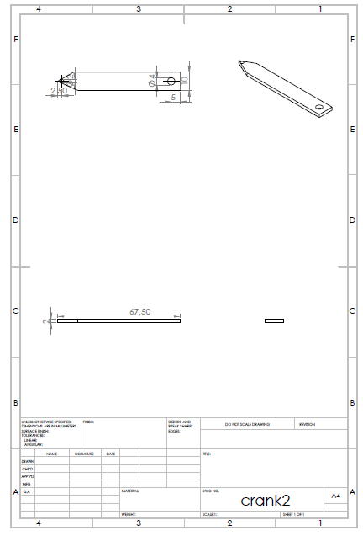

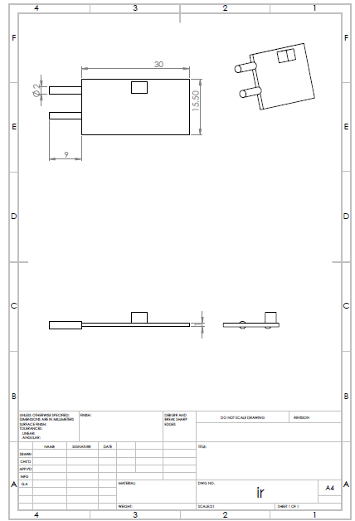

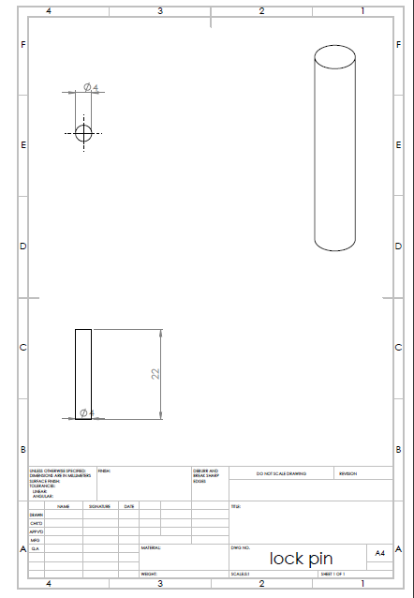

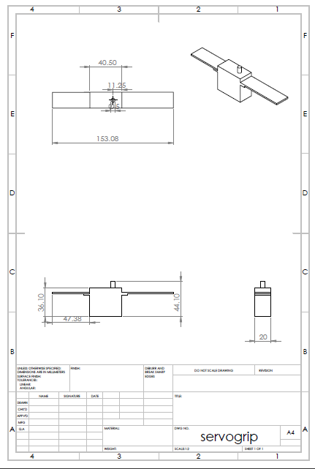

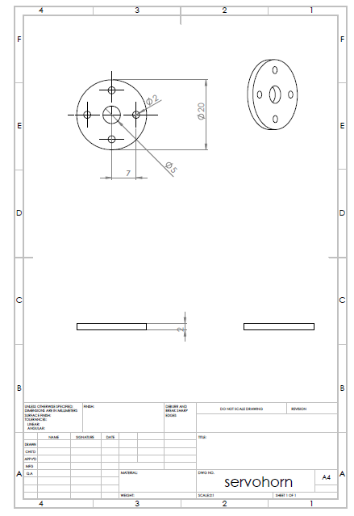

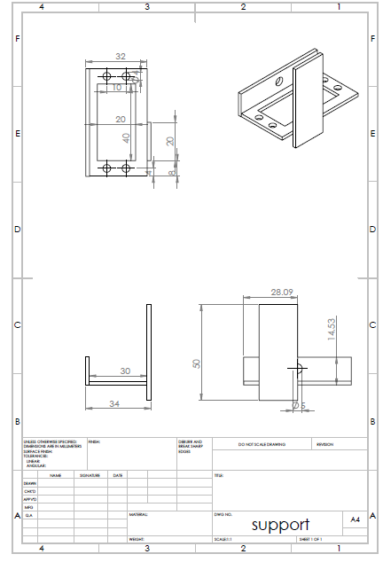

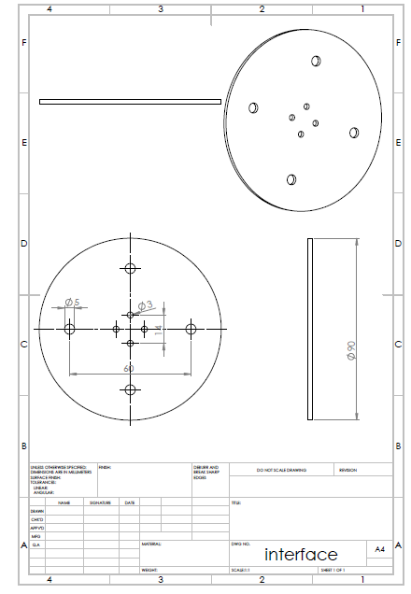

# Software Description

The controlling of the system is done using Arduino Nano microcontroller. The controller is given commands with Serial port and the connections are as provided in diagram above. The Arduino code for the system is:

*#include <Servo.h>*

*int p=0;*

*Servo grip;*

*Servo pitch;*

*Servo yaw;*

*Servo roll;*

*String s="";*

*//the servos for roll, pitch and yaw are to be separately controlled by the robot using vision-based system and inverse kinematics*

*//the input string is of format r120080040 where 120 is angle for pitch servo,80 for yaw and 40 for roll.*

*//If the input string is "pick" the grip will close.*

*// If the input string is "release" the grip will open.*

*void setup() {*

*Serial.begin(9600);*

*grip.attach(3);*

*roll.attach(5);*

*yaw.attach(6);*

*pitch.attach(9);*

*pinMode(10,INPUT);*

*}*

*void loop() {*

*if(p==1)*

*{*

*if(digitalRead(10)==1)*

*{*

*Serial.println("itemFell");*

*Serial.write('f');//object fell*

*}*

*}*

*int d=0;*

*grip.write(0);//open position*

*if(Serial.available())*

*{*

*String s=Serial.readString();*

*if(s=="pick")*

*{ grip.write(130);//close position*

*delay(500);//delay to pick*

*if(digitalRead(10)==0)*

*{*

*p=1;*

*Serial.println("ItemPicked");*

*Serial.write('p');//indicating item picked*

*}*

*else*

*{*

*Serial.println("Item not picked");*

*Serial.write('n');//indicating item not picked*

*}*

*}*

*else if (s=="release")*

*{grip.write(0);//open position*

*delay(500);*

*p=0;*

*Serial.println("ItemReleased");*

*Serial.write('q');//indicating item released*

*}*

*else*

*{*

*if(s[0]=='r')*

*{*

*if(p==1)*

*{*

*if(digitalRead(10)==1)*

*{*

*Serial.println("Item fell");*

*Serial.write('f');//object fell*

*}*

*}*

*char a=s[1];char b=s[2];char c=s[3];char d=s[4];char e=s[5];char f=s[6];*

*String api=String(a+b);*

*int apitch=api.toInt();*

*pitch.write(apitch);*

*delay(500);*

*Serial.println("moving pitch to :"+apitch);*

*String aya=String(c+d);*

*int ayaw=aya.toInt();*

*yaw.write(ayaw);*

*delay(500);*

*Serial.println("moving yaw to :"+ayaw);*

*String aro=String(e+f);*

*int aroll=aro.toInt();*

*roll.write(aroll);*

*delay(500);*

*Serial.println("moving roll to :"+aroll);*

*}*

*else*

*{*

*Serial.println("Incorrect input ");*

*Serial.write('w');//incorrect input*

*}*

*}*

*}*

}

The flow chart of the program is as follows:

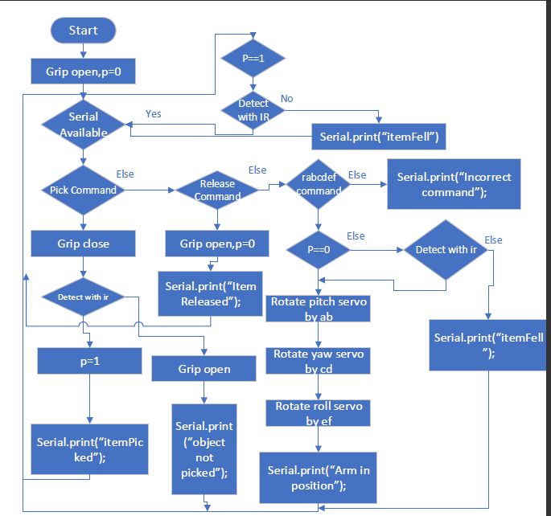

# Estimated Cost

|  |  |  |  |  |
| --- | --- | --- | --- | --- |
| No | Part | Model | Cost ( Indian Rupee) | site |
| 1 | Base plate1 | …. | 100 |  |
| 2 | Pitch Motor | Metal Gear Dual Shaft 16kgcm Digital Servo Motor | 1350 | https://robokits.co.in/motors/rc-servo-motors/metal-gear-dual-shaft-16kgcm-digital-servo-motor |
|  |  |  |  |
| 3 | Servo plate 1 |  | 120 |  |
| 4 | Base plate2 | …. | 100 |  |
| 5 | Yaw Motor | Metal Gear Dual Shaft 16kgcm Digital Servo Motor | 1350 | <https://robokits.co.in/motors/rc-servo-motors/metal-gear-dual-shaft-16kgcm-digital-servo-motor> |
|  |  |  |  |
| 6 | Servo plate 2 |  | 120 |  |
| 7 | Roll motor | TowerPro MG995 Metal Gear Servo Motor | 325 | https://robu.in/product/towerpro-mg995-metal-gear-servo-motor/ |
|  |  |  |  |
| 8 | Grip Servo | TowerPro MG995 Metal Gear Servo Motor | 325 | https://robu.in/product/towerpro-mg995-metal-gear-servo-motor/ |
|  |  |  |  |
| 9 | Servo Horn | Metal Horn for Servo 25T | 90 | <https://robokits.co.in/motors/rc-servo-motors/metal-horn-for-servo-25t> |
|  |  |  |  |
| 10 | IR Sensor Module |  | 47 | https://robokits.co.in/sensors/ir-and-pir-sensors/ir-obstacle-sensor-module |
|  |  |  |  |
| 11 | Linkage Support |  | 100 |  |
| 12 | Crank 1 |  | 20 |  |
| 13 | Crank 2 |  | 20 |  |
| 14 | Lock pin 1 |  | 20 |  |
| 15 | Lock pin 2 |  | 20 |  |
| 16 | Arm 1 |  | 30 |  |
| 17 | Arm 2 |  | 30 |  |
| 18 | Rubber Shoe 1 |  | 40 |  |
| 19 | Rubber Shoe 2 |  | 40 |  |
| 20 | Gripper Motor Support |  | 100 |  |
| 21 | Arduino nano |  | 250 | https://robu.in/product/arduino-nano-board-r3-with-ch340-chip-wo-usb-cable-solderedarduino-nano-r3-wo-usb-cable-soldered/ |
|  |  |  |  |
| 22 | 7 volt/ 3 Amp Adapter |  | 600 |  |
| 23 | Interface plate |  | 150 |  |
| 24 | Electronic Box |  | 100 |  |
|  |  | **Total** | **5447** |  |
|  |  |  |  |  |

# Maintenance projection

1. The Rubber Shoes can get warn out after continuous use.Their Maintainance has to be done by observing the state of serrations on the shoes.
2. The Motors are to be tested Regularly.